**FYP-I**

**Project Proposal**

Group Members:

Hasan Imran -11459

Saad Salman - 11474

Ammar Saleem - 11479

Goal:

To predict the likelihood/certainty that a customer will buy the product.

Project Outline:

We wish to develop a program that can predict the likelihood/certainty that a customer will buy a product that he is interested in based on his social media posts such as **Twitter** tweets and if possible his recent browsing history as well. This will help the company/business target that particular customer more efficiently and boost its sales.

Software Development Model:

Agile Manifesto

Issues:

* Currently we have many recommendation systems available which recommend different products to the user, most of which are not efficient.
* No such effective model for businesses to identify potential customers.
* There is a lack of understanding the way in which social network members elect to purchase something.

Solutions:

* We want to develop a software that will help the businesses identify potential customers for their products.
* Our approach not only understands the message that is posted, but also why it is posted, the relations between this post and older posts, etc. in relation to the target product.

3 discrete steps in online buying behavior which we want to model

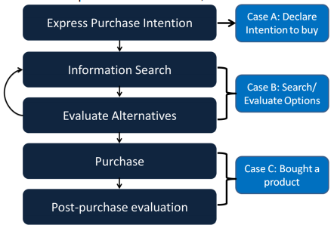

Our approach:

* We will be searching for Twitter tweets of potential customers wanting to buy a product. And based on those tweets we will estimate/predict the likelihood that the customer will buy the product.
* We will make a model by gathering tweets from users who have already expressed intention to buy the product and see their tweet history and if possible their web search history as well.
* Using this model, we will input potential customers who have tweeted about the product but have not bought it. And based on the training data the model will estimate a prediction/likelihood of whether the customer will buy it or not.
* We will limit the scope of our data to only using mobile phones. And our model will predict the consumer intention for the latest upcoming mobile phones by gathering data and updating the model at fixed intervals.
* We plan to generate a trending list of phones on twitter which will be launching soon or have been recently launched and the users can use that list of products on our application to find customer for that product/mobile phone.

Project Development Tools:

Development Environment:

Application Development:

Database: MongoDB

Programming Language: Python/Java

How to gather data:

<https://github.com/jonbakerfish/TweetScraper>

TweetScraper is a Scrapy crawler/spider for Twitter Search without using API